Biology 202
Total: / 25 Points
1.10 Lab: Scientific Method
Objectives:
1. Understand the relationship between an independent variable and a dependent variable.
2. Understand the significance of the control group.
3. Explain the difference between inference and observation.
4. Draw conclusions from evidence.

Part 1: Observation and Inference (6 pts)
Inference is an assumption made from observation. Observation can be said to be a factual description, inference is an explanation to the collected data. Inference is the conclusion drawn out of keen observation. One can make a valid inference only if there is enough data or evidence.
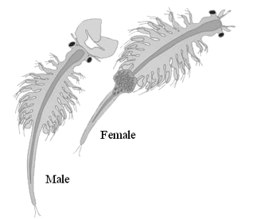
Observe the illustration (right) and then watch the following video (you may want to mute it): http://quietube6.com/v.php/http://www.youtube.com/watch?v=dYE4Y6p-Lf4
Make three observations about the brine shrimp, and list them in the table below. Then list three inferences that you have made from those observations. (3 pts)
Observations | Inferences
1. | 4.
2. | 5.  www.thefishsite.com
3. | 6.

7. How valid do you feel your inferences are? Please respond in a complete sentence or two. (1 pt)

8. What additional information could you seek to increase the validity of your inferences? (2 pts)
Part 2: Control Groups and Experimental Variables (4 pts)
In the experiment shown below, scientists tested to see if the amount of detergent in the brine shrimps’ environment affected the survival of the brine shrimp.
Only one variable was changed … This is the independent variable (the condition that is purposely changed or altered). All other conditions of the experiment remained the same (constant). The response to the change (the thing that is measured) is the dependent variable.
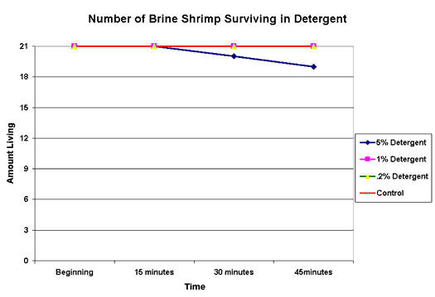

9. Develop a hypothesis for the experiment shown above. Remember to phrase it as an “if/then” statement. (2 pts)

10. In the experiment above, which was the dependent variable? (1 pt)

11. Which was the independent variable? (1 pt)
Part 3: Drawing Conclusions from Evidence (15 pts)
Take a look at the graph (below) to answer the following questions.
In this experiment, scientists looked at how the concentration of calcium in the brine shrimps’ environment affected the number of eggs that hatched.
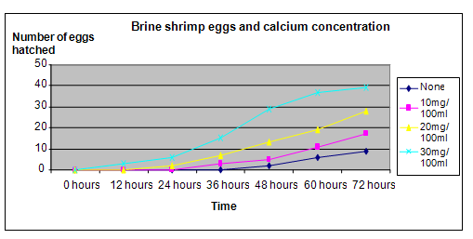
http://www.all-science-fair-projects.com/print_project_1427_103
12. Develop a hypothesis for the experiment shown above. Remember to phrase it as an “if/then” statement. (2 points)

Circle or underline the correct answer:
13. In the experiment above, the (independent, dependent) variable is the concentration of (0mg/100ml or no calcium, 10mg/100ml, 20mg/100ml or 30mg/100ml) in water. (2 points)
14. The (independent, dependent) variable is the number of brine shrimp eggs that successfully hatch. (1 points)
15. List three constants (conditions that remain the same) in this experiment. (3 points)
Constant #1:
Constant #2:
Constant #3:

Use the table (below) to answer the following questions:
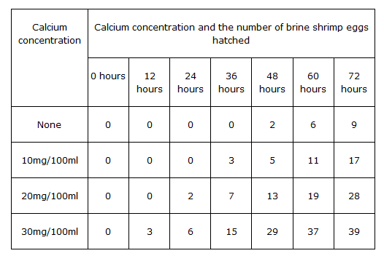
A scientific control is an important part of the scientific method. No treatment is given to the control group, while the experimental group is changed according to some variable of interest. The control minimizes the effect of variables other than the single independent variable and acts as a comparison for the results.
16. In the experimental data in the table, how many eggs have hatched in the control group? (2 points)
a.) After 48 hours?
b.) After 72 hours?
17. True or False? An environment containing no calcium is the best for brine shrimp egg hatching. Provide evidence in the form of observations from the data table above to support your selected response. (2 points)

18. What conclusions can be drawn from the evidence about the optimum temperature for brine shrimp eggs hatching? HINT: Does a high or low calcium concentration result in more hatched eggs? What data supports your conclusion? (3 points)

