CC Recording from 1/27/14
Mrs. Ulry’s Guided Notes Template (10 pts)
“Agenda for Today”
Topic #1:
Strategies for _____Type Answer HERE__________________
Topic #2:
_____Type Answer HERE__________________
“Achieving Success”
Steady pace needed for _____Type Answer HERE__________________
“My Expectation”
_____Type Answer HERE___hours per week; 60-90 minutes for each daily assignment
“Weekly Breakdown”
_____Type Answer HERE____: in CC; required for students with sem1 grade less than 805 (B-)
_____Type Answer HERE____: Completion of daily work
_____Type Answer HERE____: Studying lesson content
“Let’s Get Started”
Before starting to work on daily assignment, download the _____Type Answer HERE____ so you can use it for _____Type Answer HERE____.
“Lesson Page 1” and “Lesson Design”
Green Box  Info Category:  Lesson Number and Name  Ex. info based on 1.02  _____Type Answer HERE____  Brown Box  Info Category:  Main Idea  Ex. info based on 1.02  _____Type Answer HERE____  Black Box  Info Category:  Information you are to learn  Ex. info based on 1.02  _____Type Answer HERE____  Orange Box (name of visual)  Info Category:  Mind Map  Purpose for graphic:  _____Type Answer HERE____ | 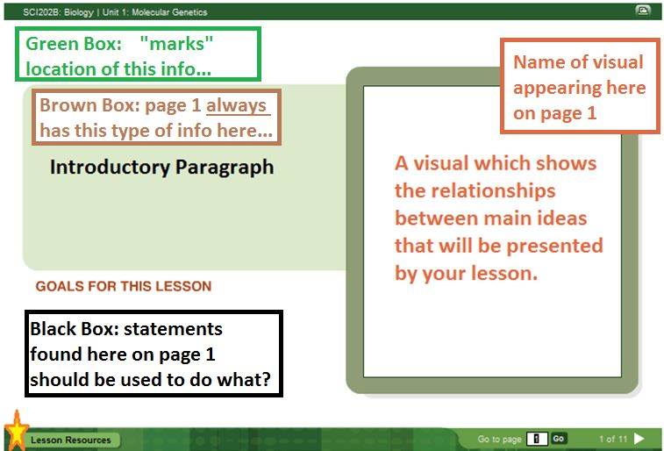

“Essential Question”
How is _____Type Answer HERE____ processed by _____Type Answer HERE____?
When given more specific statements about the content that you need to learn, referred to as:
_____Type Answer HERE____OR _____Type Answer HERE____
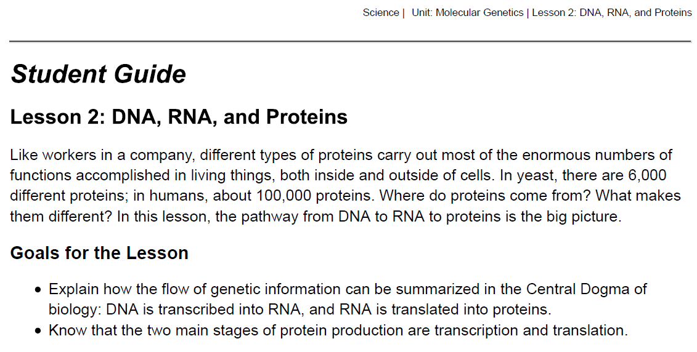
Genes in DNA are transcribed into RNA, and RNA is translated into various types of proteins.
(Above sentence is the heading from slide p #1)
See notes from “Lesson Page 1” and “Lesson Design” Presentation Slides above
The flow of information from DNA to RNA to proteins is a central principle in biology.
(Above sentence is the heading from slide p #3)
Function of _____Type HERE____ = genes are specific segments that _____Type HERE____ directions for building _____Type HERE____
Ex. _____Type HERE____ store directions for building many different structures
Function of _____Type HERE____ = interprets the information contained by _____Type HERE____
Ex. Contractor uses _____Type HERE____to guide building process
Function of Protein = carry out _____Type HERE____
Ex. A completed _____Type HERE____ is made up of many different structures and each has a specific job or purpose. Doors to enter / exit, roof to protect from weather and windows for air flow.

RNA molecules are transcribed from DNA codes and translated into 3-D protein structures.
(Above sentence is the heading from slide p #4)
Two Parts or Processes Involved:
- DNA found in a cell’s _____Type HERE____ is made into _____Type HERE____ (transcribed)
Ex. Scribes make copies of a document by transcribing the information.
- RNA travels from nucleus and into the cell’s _____Type HERE____ to ribosomes where _____Type HERE____ are built of polypeptides (translated)
Ex. ?? Translation occurs when changing from one language to another
Many different types of proteins exist in living things.
(Above sentence is the heading from slide p #5)
Proteins show great _____Type HERE____ in shape and function.
Protein Types (seems to suggest different protein _____Type HERE____) include:
- _____Type List HERE____
- _____Type List HERE____
- _____Type List HERE____

Proteins have many _____Type HERE____ (or jobs) including:
- _____Fill-in with appropriate phrase HERE____ molecules across a cell membrane during active transport
- _____Type specific function HERE____ in the form of antibodies and regulation of metabolism.
- _____Type List HERE____
- _____Type List HERE____

Proteins can be enzymes, or they can be used for transport or storage.
(Above sentence is the heading from slide p #6)
ATPase belongs to one class of proteins called _____Type HERE____.
_____Type HERE____ helps with breaking down of ATP into ADP by speeding up the _____Type HERE____.
Proteins can cause movement and can be formed into structures.
(Above sentence is the heading from slide p #7)
Movement of _____Type HERE____. occurs with the help of two different contractile proteins: _____ID by name HERE____.
Structural proteins are used to build _____Type HERE____ (of fibroin) and form hair, _____Type TWO Examples HERE____ (of keratin).
The immune system and maintenance of metabolism include the actions of many proteins.
(Above sentence is the heading from slide p #8)
_____Type HERE____ are specialized proteins of the immune system that protect the body by destroying _____Type HERE____.
_____Type HERE____. proteins affect an organism’s metabolism and this includes hormones.
Ex. _____Type HERE____ influences sleep, mood and _____Type HERE____..
To summarize, parts of the DNA code are transcribed into RNA, and RNA is used to build proteins.
(Above sentence is the heading from slide p #9)
Many different types of _____Type HERE____ exist and they can be found inside _____Type HERE____ as well as outside of the _____Type HERE____.
All proteins are produced _________________Type HERE________________:
- DNA is_____Type HERE _____into RNA
- RNA is then _____Type HERE _____into proteins.

Keywords and Pronunciations – Vocabulary List for Unit 1
1.02 slide p #3
DNA: deoxyribonucleic (dee-AHK-sih-riy-boh-nyoo-KLEE-ihk) acid; this is the molecule, unique to each individual, carrying the genetic information to be found in every cell; all the information an organism needs to live and reproduce is contained in its DNA
RNA: ribonucleic (RIY-boh-nyoo-KLEE-ihk) acid; nucleic acid that uses the instructions stored in DNA to build proteins
Proteins: one of the four major classes of large organic molecules, made of amino acids
1.02 slide p #4
gene: a segment of DNA that directs the development of some inherited traits
1.02 slide p #5
transcription: the synthesis of an RNA molecule using a DNA molecule for a template
translation: the process in which proteins are produced based on instructions carried by mRNA
1.02 slide p #6
enzyme ( EN-ziym ): a protein that is a catalyst for chemical reactions in organisms; it increases the rate of the reaction without being used up or changed
adenosine triphosphate ( uh-DEH-nuh-seen triy-FAHS-fayt ): ATP; the molecule that delivers usable chemical energy for almost all processes and reactions that a cell must undergo to survive
1.02 slide p #7
fibroin ( FIY-bruh-wuhn) and keratin ( KEHR-uh-tn) – specific examples of structural proteins
1.02 slide p #8
serotonin ( sihr-uh-TOH-nuhn): protein that acts as a hormone involved with regulation of sleep, mood and appetite

